ELECENG 3CL4 – Lab 4
Phase Lead Compensation Using Root Locus

March 20th, 2026

Amaiam Ul Haque – haquea24 – 400520641 – L07 – C02
Jumana Ismail – ismailj – 400507846 – L07 – C02

Plagiarism Statement
As a future member of the engineering profession, the student is responsible for performing the required work in an honest manner, without plagiarism and cheating. Submitting this work with my name and student number is a statement and understanding that this work is my own and adheres to the Academic Integrity Policy of McMaster University and the Code of Conduct of the Professional Engineers of Ontario. Submitted by [Amaiam Ul-Haque, haquea24, 400520641]
As a future member of the engineering profession, the student is responsible for performing the required work in an honest manner, without plagiarism and cheating. Submitting this work with my name and student number is a statement and understanding that this work is my own and adheres to the Academic Integrity Policy of McMaster University and the Code of Conduct of the Professional Engineers of Ontario. Submitted by [Jumana Ismail, ismailj, 400507846]

Individual Contributions
- Pre Lab Report: both
- Design of Phase-Lead Compensator: both
- Experiment with Phase Lead Compensator: both
- Post Lab Report:
  - Typing Calculations: Amaiam
  - Formal Write Up: Jumana

Introduction
IDK, SOMETHIING

Phase-Lead Control of the Servomechanism

Design of Phase-Lead Compensator
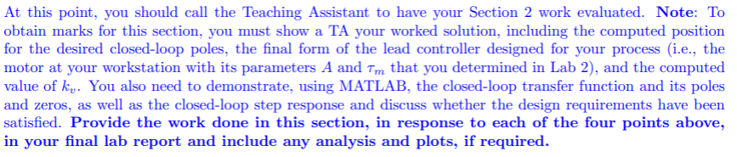
The transfer function of the plant / motor is as follows:
$$G\left(s\right)=\frac{A}{s\left(sτ_{m}+1\right)} =\frac{A/τ_{m}}{s\left(s+\frac{-1}{τ_{m}}\right)}$$

Given the lab station specific parameters: $A=29.34 , τ_{m}=0.0941$
$$G\left(s\right)=\frac{29.34}{s\left(0.0941s+1\right)} =\frac{311.8}{s\left(s+10.63\right)}$$

Given design requirements of $PO=10\% , T_{s}=0.3s$

To calculate the desired closed loop pole locations based on overshoot and settling time:
$$T_{s}=\frac{4}{real part of poles} \\ real part of poles=\frac{4}{T_{s}}=\frac{4}{0.3}=13.33$$
$$ζ=\frac{-\ln\left(\frac{PO}{100}\right)}{\sqrt{π^{2}±\ln^{2}\left(\frac{PO}{100}\right)}}=\frac{-\ln\left(0.1\right)}{\sqrt{π^{2}±\ln^{2}\left(0.1\right)}}=0.591 \\ ζ=cosθ \\ θ=\cos^{-1}{ζ=}\cos^{-1}{0.591}=53.772°$$
$$tanθ=\frac{opp}{adj}=\frac{y}{x} \\ y=xtanθ=real part of poles×tanθ=13.33\tan\left(53.772\right)=18.19 \\ img part of poles= ±18.19j$$
$$poles= -13.33±18.19j$$
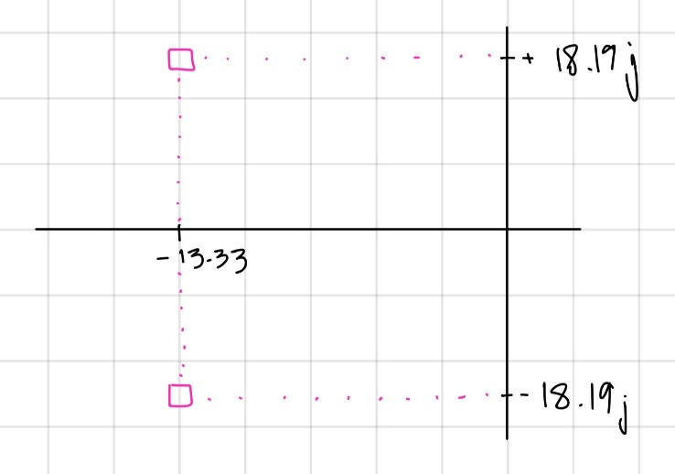

To calculate the phase lead compensator parameters $p, z$:
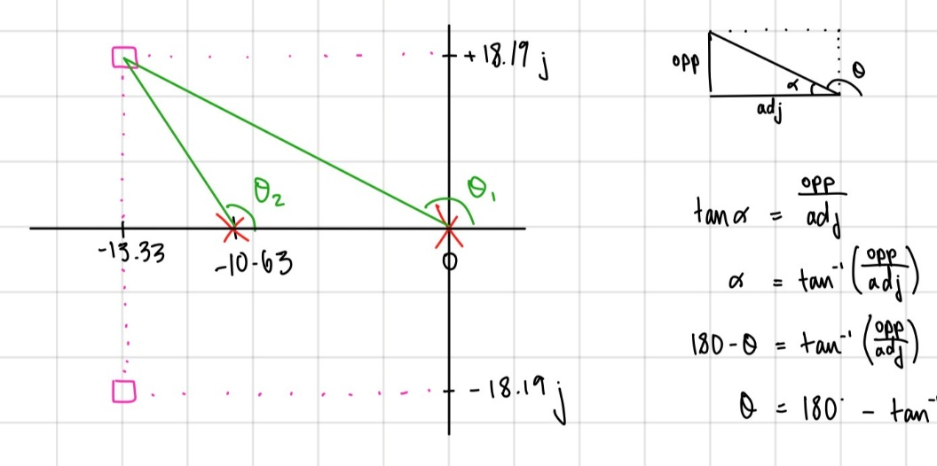
$$tanα=\frac{opp}{adj} \\ α=\tan^{-1}\left(\frac{opp}{adj}\right) , α=180°-θ \\ {180°-θ=tan}^{-1}\left(\frac{opp}{adj}\right) \\ {θ=180°-tan}^{-1}\left(\frac{opp}{adj}\right)$$

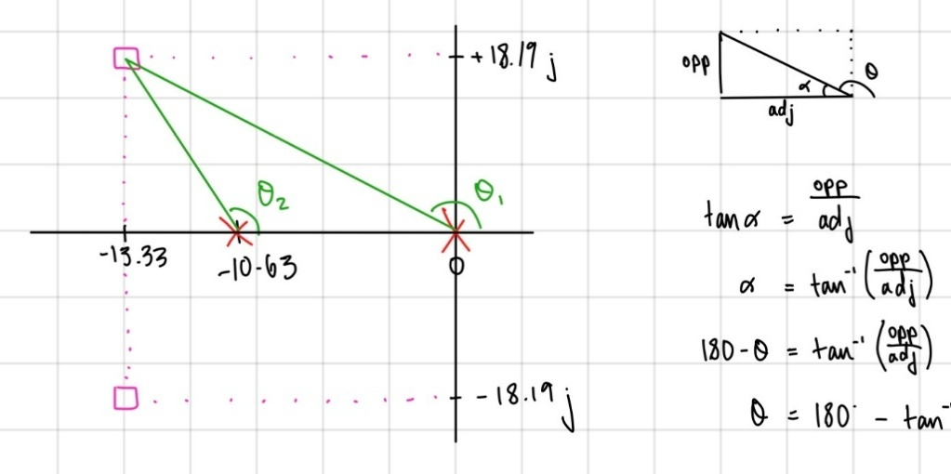
$${θ_{1}=180°-tan}^{-1}\left(\frac{opp}{adj}\right)={180°-tan}^{-1}\left(\frac{18.19}{13.33}\right)=126.23° \\ {θ_{2}=180°-tan}^{-1}\left(\frac{opp}{adj}\right)={180°-tan}^{-1}\left(\frac{18.19}{13.33-10.63}\right)=98.44° \\ 180°=ϕ_{c}-θ_{1}-θ_{2} \\ ϕ_{c}=-θ_{1}-θ_{2}-180°=-126.23-98.44-180=404.67=404.67-360=44.67°$$
$$θ_{z}=directly under σ_{A}=90° \\ ϕ_{c}=θ_{z}-θ_{p} \\ θ_{p}=θ_{z}-ϕ_{c}=90-44.67=45.33°$$

$$-z=-σ_{A} \\ -z=-13.33 \\ z=13.33$$

$$tanθ=\frac{y}{x} \\ x=\frac{y}{tanθ} , x=p-real part of pole=p-σ_{A} \\ p-σ_{A}=\frac{y}{tanθ} \\ p=\frac{y}{tanθ}+σ_{A}=\frac{18.19}{\tan\left(45.33\right)}+13.33=31.31$$

$$z=13.33, p=31.31$$
To sketch the root locus pic:
Relevant part of open loop transfer function: $P\left(s\right)=\frac{s+z}{s+p} ×G\left(s\right)=\frac{s+13.33}{s+31.31}×\frac{1}{s\left(s+10.63\right)}$
$$\# of open loop poles:n=3 \\ \# of open loop zeros:M=1 \\ \# of asymptotes:n-M=2 \\ angles: ϕ=\left(2l+1\right)\frac{180°}{n-M}=\left(2l+1\right)\frac{180°}{2}=\left(2l+1\right)90=90°, 270°→l=0,1 \\ centroid: σ_{A}=\frac{∑ pole positions-∑zero positions}{n-M}=\frac{31.31+10.63+0-13.33}{2}=14.3$$

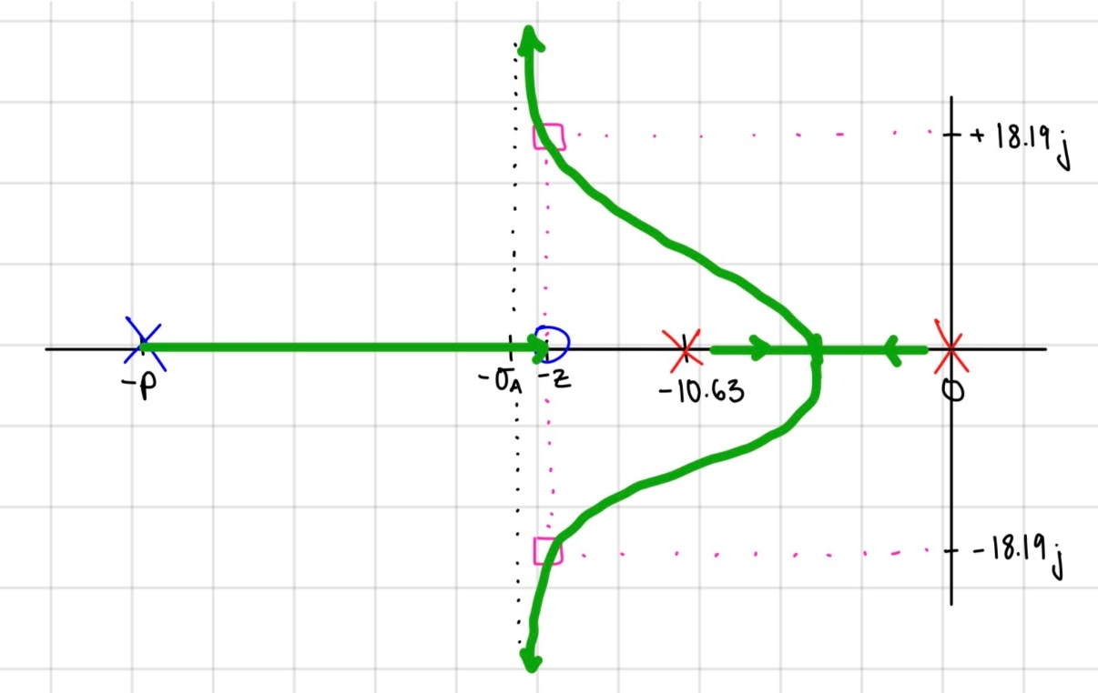

Using magnitude criterion to calculate the corresponding $k_{c}$:
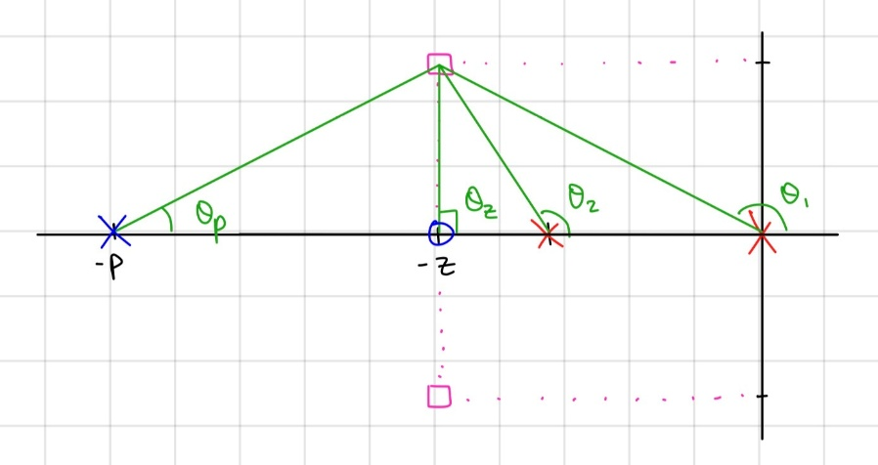
$$d=\sqrt{x^{2}+y^{2}} \\ d_{1}=\sqrt{{13.33}^{2}{+18.19}^{2} }=22.55$$
$$d_{2}=\sqrt{{(13.33-10.63)}^{2}{+18.19}^{2} }=18.39$$
$$d_{p}=\sqrt{{(31.31-13.33)}^{2}{+18.19}^{2} }=25.58$$
$$d_{z}=y=18.19$$

$$1=\left|G_{c}\left(s_{o}\right)G\left(s_{o}\right)\right| \\ k_{c}\left|\frac{s_{o}+z}{s_{o}+p}\right|=\frac{1}{\left|G_{c}\left(s_{o}\right)G\left(s_{o}\right)\right|} \\ k_{c}=\frac{1}{\left|G_{c}\left(s_{o}\right)G\left(s_{o}\right)\right|}×\left|\frac{s_{o}+p}{s_{o}+z}\right|=\frac{1}{311.8}×\frac{d_{1}d_{2}d_{p}}{d_{z}}=\frac{22.55×18.39×25.58}{311.8×18.19}=1.87$$
$$k_{c}=1.87$$
Resulting transfer functions:
$$∴G_{c}\left(s\right)=k_{c}\frac{s+z}{s+p}=1.87×\frac{s+13.33}{s+31.31}$$
$$L\left(s\right)=G_{c}\left(s\right)G\left(s\right)=k_{c}\frac{s+z}{s+p}×\frac{\frac{A}{τ_{m}}}{s\left(s+\frac{-1}{τ_{m}}\right)}=1.87×\frac{s+13.33}{s+31.31}×\frac{311.8}{s\left(s+10.63\right)}$$

To calculate the velocity error constant, $k_{v}$:
$$k_{v}=\lim_{s→0}{sG_{c}\left(s\right)G\left(s\right)=\lim_{s→0} 1.87s×\frac{s+13.33}{s+31.31}×\frac{311.8}{s\left(s+10.63\right)}=\frac{1.87(13.33)311.8}{31.31(10.63)}=23.35}$$
$$∴k_{v}=23.35$$

INSERT MATLAB SHENANIGANS
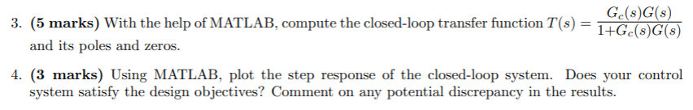
MATLAB Code:
s = tf('s'); %tf = transfer function, s laplace var

G = 311.8 / ((s)*(s + 10.63));

Gc = 1.87 * (s+13.33)/(s + 31.31);

% Closed-loop transfer function
T = feedback(Gc*G, 1); %closed loop functoin , H(s) = 1

% Display transfer function
T

% Poles and zeros
p = pole(T)
z = zero(T)

step(T) %step input
grid on
stepinfo(T) %gives plot response information

Code’s Output:
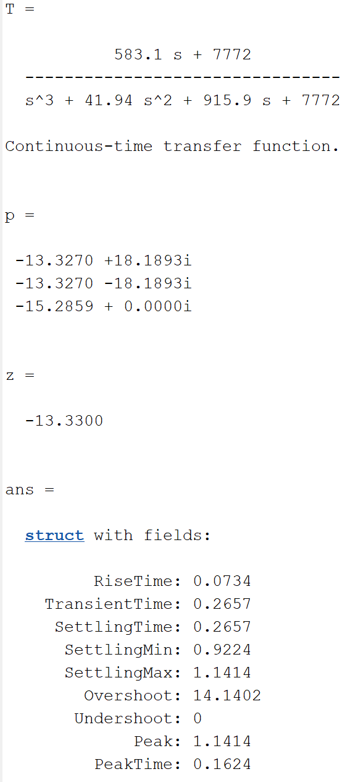
Step Response Plot:
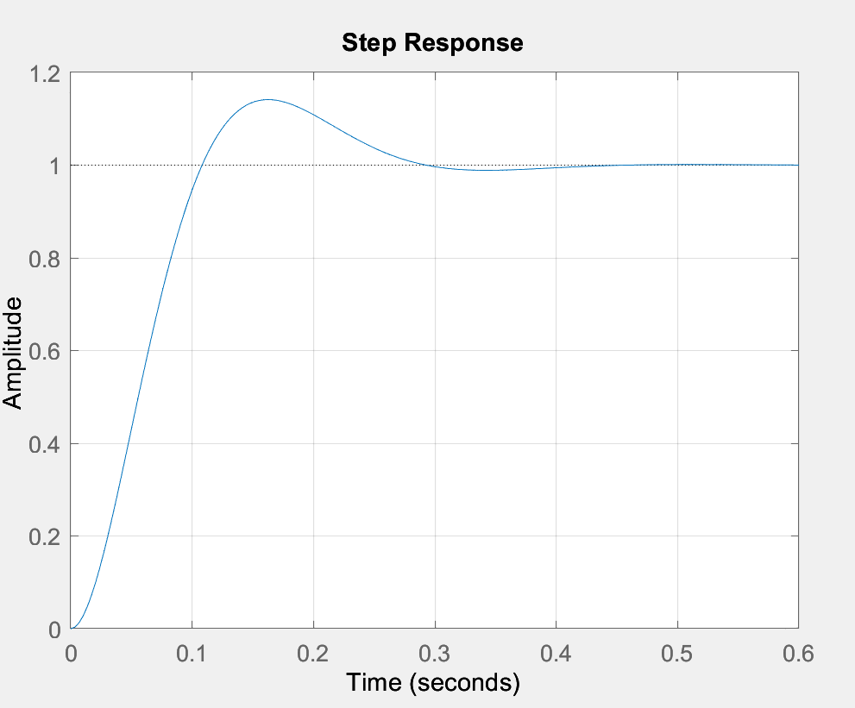

As seen from the above data and plot, there is an overshoot of approximately 14.14% and a settling time of around 0.27s. Thus, the Ts does meet the design requirement, but the P.O. is over the required P.O. of 10% this overshoot may be due to the fact that we our motor transfer function is of a second order, however when adding Kc, Kc has a zero thus we are adding a derivative which is 1/s (the integrator) thus the system becomes a third order so our design requirement is not met perfectly.

Experiment with Phase Lead Compensator

Step Response
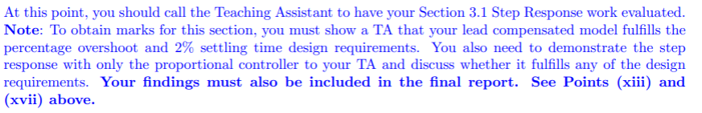

Using the following Simulink model in MATLAB:
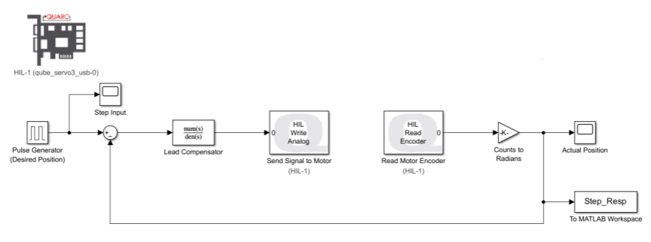
Results in the following experimental output:
INSERT GRAPH PIC W/ TRANSFER FUNCTION BLOCK
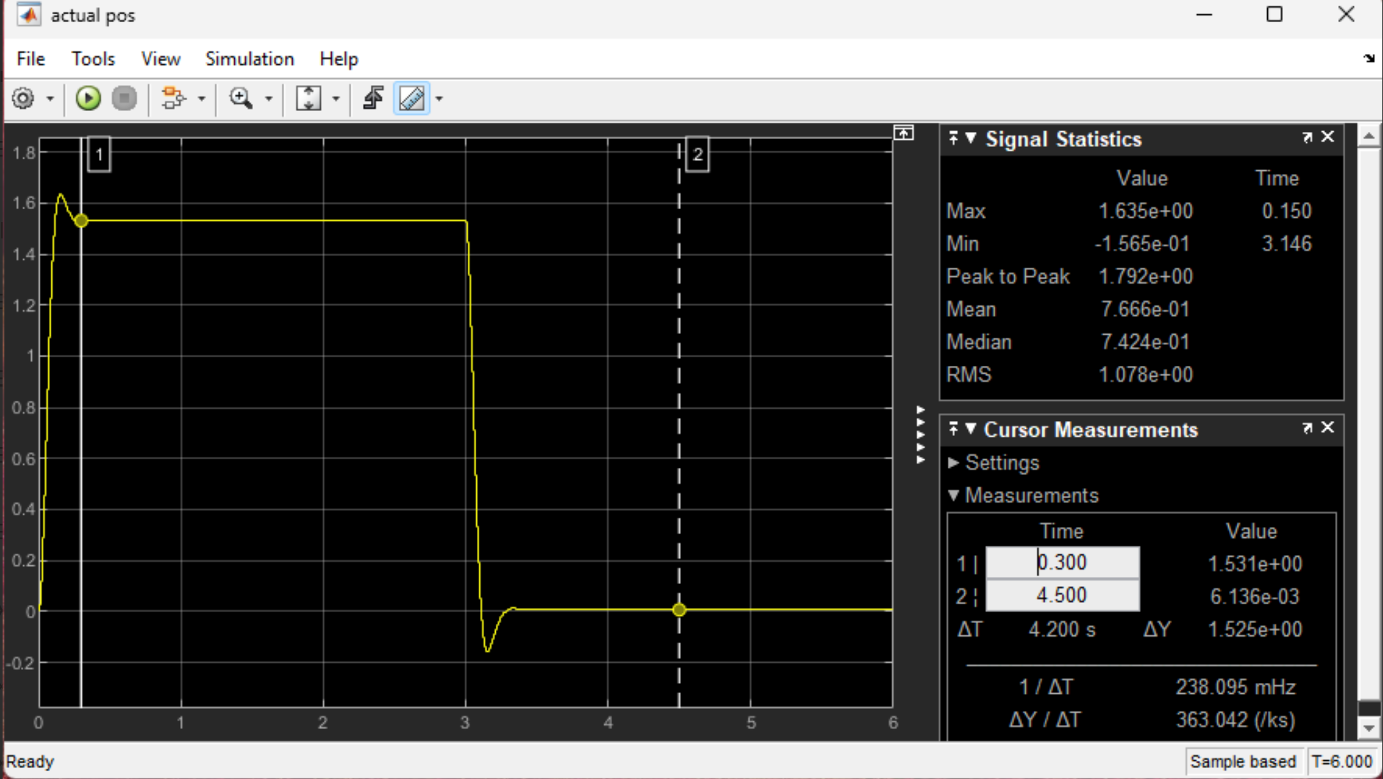

Verifying the control system design objectives are satisfied:
$$M_{p}=1.635 \\ f_{v}=1.531 \\ PO=\frac{M_{p}-f_{v}}{f_{v}}×100=\frac{1.635-1.531}{1.531}×100=6.8\% \\ T_{s}=0.3s$$
$$∴PO=6.8\% , T_{s}=0.3s$$

ANSWER PART XIII) + TALK ABOUT CORRESPONDING EXPLANATION ABOUT HOW OUR MOTOR PARAMETERS MAY HAVE DISCREPENCIES PRESENT WHICH CAUSES THE INACCURATE/BELOW REQUIREMENT PO
As seen from our P.O., it is under the requirements of the design i.e. P.O. of around 10% however our Ts does meet the requirements. Our values and experiments were checked by the TA and our TA confirmed that the issue is with motor it self as it would have given innacuarate A and tm values from experiment 2, thus when trying to meet the design constraints of this experiments in was not possible. Although, it was expected that it would if it were not for our motor station.

Using the same following Simulink model in MATLAB, but with the transfer function block replaced with a gain block of $k_{c}=1.87$:

Results in the following experimental output:
INSERT GRAPH PIC W/ GAIN BLOCK
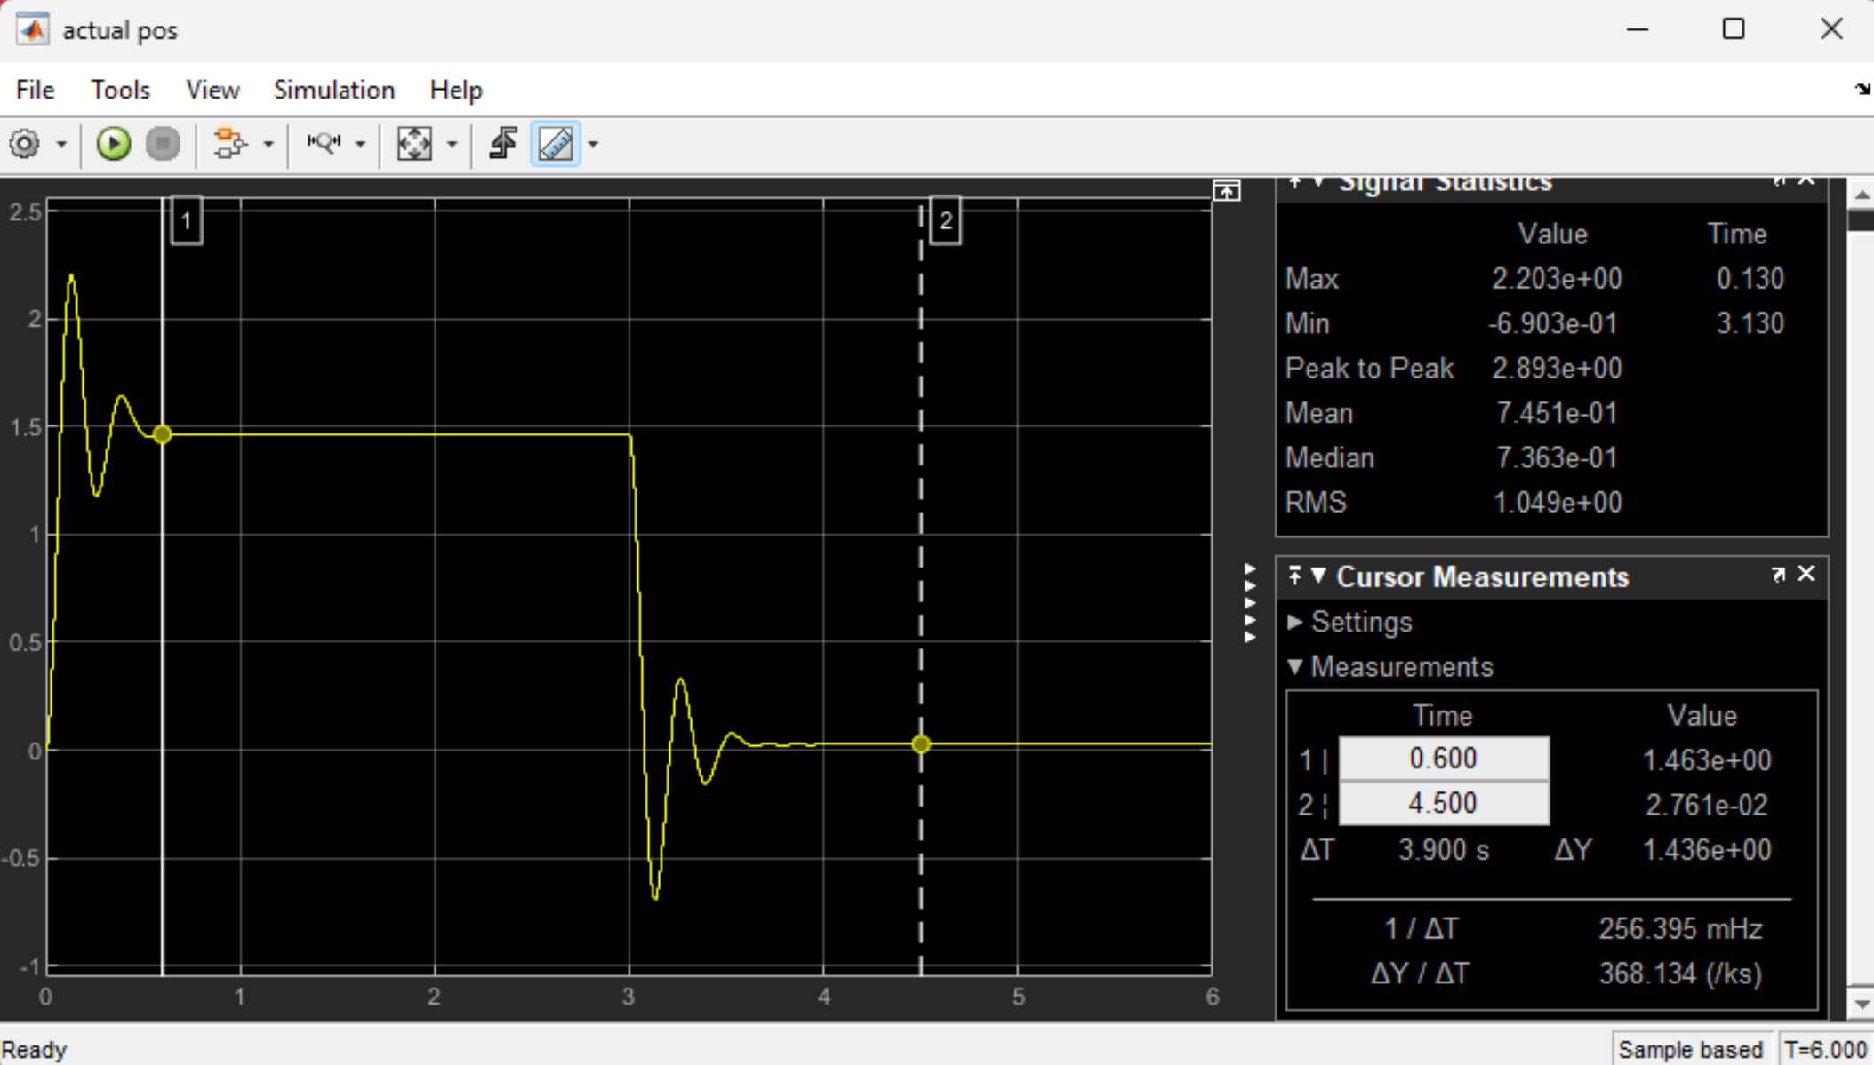
To verify the control system design objectives are satisfied:
$$M_{p}= 2.203 \\ f_{v}= 1.46 \\ PO=\frac{M_{p}-f_{v}}{f_{v}}×100=\frac{2.203-1.46}{1.46}×100=50.9\% \\ T_{s}=0.6s$$
$$∴PO=50.9\% , T_{s}=0.6s$$
ANSWER PART XVII

Ramp Response
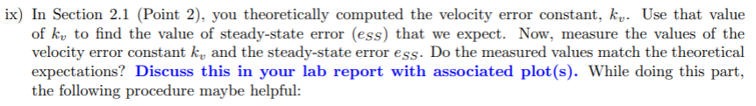
Using the following Simulink model in MATLAB:
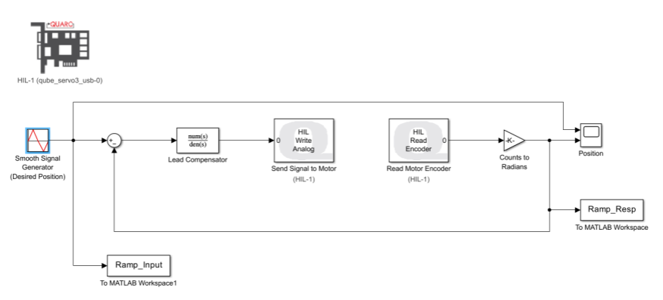

Results in the following experimental output:
INSERT GRAPH PIC W/ TWO LINES W/ CURSORS AT SAME TIME

To calculate the experimental values of $k_{v} and e_{ss}$:
$$e_{ss}=y_{output}\left(t=1.485s\right)-y_{input}y_{output}\left(t=1.485s\right)=0.3835-0.0096=0.2875 \\ k_{v}=\frac{A_{input}}{e_{ss}}=\frac{Δy/Δx}{e_{ss}}=\frac{i forgor, need to check pic, oopsies}{0.2875}=\frac{5.938}{0.2875}=20.65$$
$$∴e_{ss}=0.2875 , k_{v}=20.65$$

YIPPIE, NOW WHATEVER POST RESULTS YAP ABOUT THOERY AND EXPERIMENT MATCHING

YIPPIE
Hehe eid mubarak whenever you see this hehehehehheheeheheheheh :D

